Letter of Recommendation

TO WHOMSOEVER IT MAY CONCERN



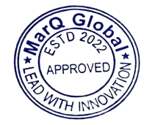
This is to certify that Mr. Md Faisal Alam successfully completed his internship as a Software Development Intern with MarQ Global from April 2025 to June 2025.
During his tenure, he displayed strong capabilities in:
• Full-Stack Web Development (Node.js, React)
• RESTful API Design & Integration
• Database Management (MongoDB)
• Agile/Scrum Collaboration
• Debugging & Problem-Solving
Md Faisal Alam proved to be professional, adaptable, and dedicated. We are confident he will be an asset to any technology or software development team.
Sincerely,

Akhil Singh
Senior Manager– Human Resources

